**Case Study: Deaths of Despair in the United States**

* What’s are the national trends in midlife mortality rates over time?
* What are the related social determinants that are associated with increased mortality?
* How do analyses differ for California and New York?

**Target Users:** Healthcare providers, payers and policy makers.

**Author:** Yuxuan Wang and Kristin Bennett

**Motivation:**

Premature Deaths overdose and self-harm in adults age 25 to 64 have increased alarmingly in the United States. The goal of this analysis is to understand how these so called “Deaths of Despair” have increased at the national, state, and county levels between 2000 and 2017 at the national, state, and county level. Then we want to understand social and economic determinants and other factors associated with higher risks of mortality. All analysis was conducted using <https://mortalityminder.idea.rpi.edu/>. Please see that site as well as <https://github.com/TheRensselaerIDEA/MortalityMinder/wiki> for data sources, definitions, and details of the analysis methods.

**Step 1: National mortality overview**

When we first navigate to the Mortality Minder (MM) page, we could immediately get an overview of mortality distribution over the years. By clicking on different “Period Buttons”, e.g. “2000-02”, we could investigate the geographical distribution of mortality rate quickly.

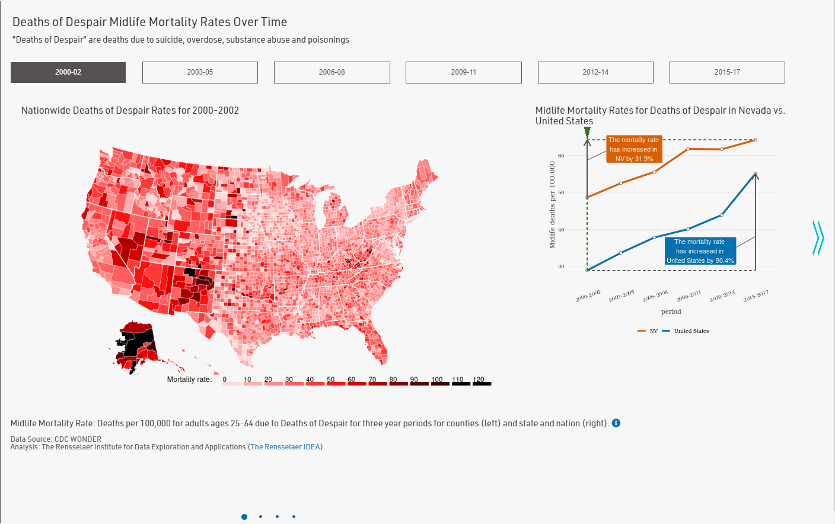2000-2002 National Mortality Distribution:

As we can tell from the transparency of color, the eastern part and mid-part are doing much better than the western part on average: around 10-30 per 100,000 compared to more than 50 per 100,000 thousands.

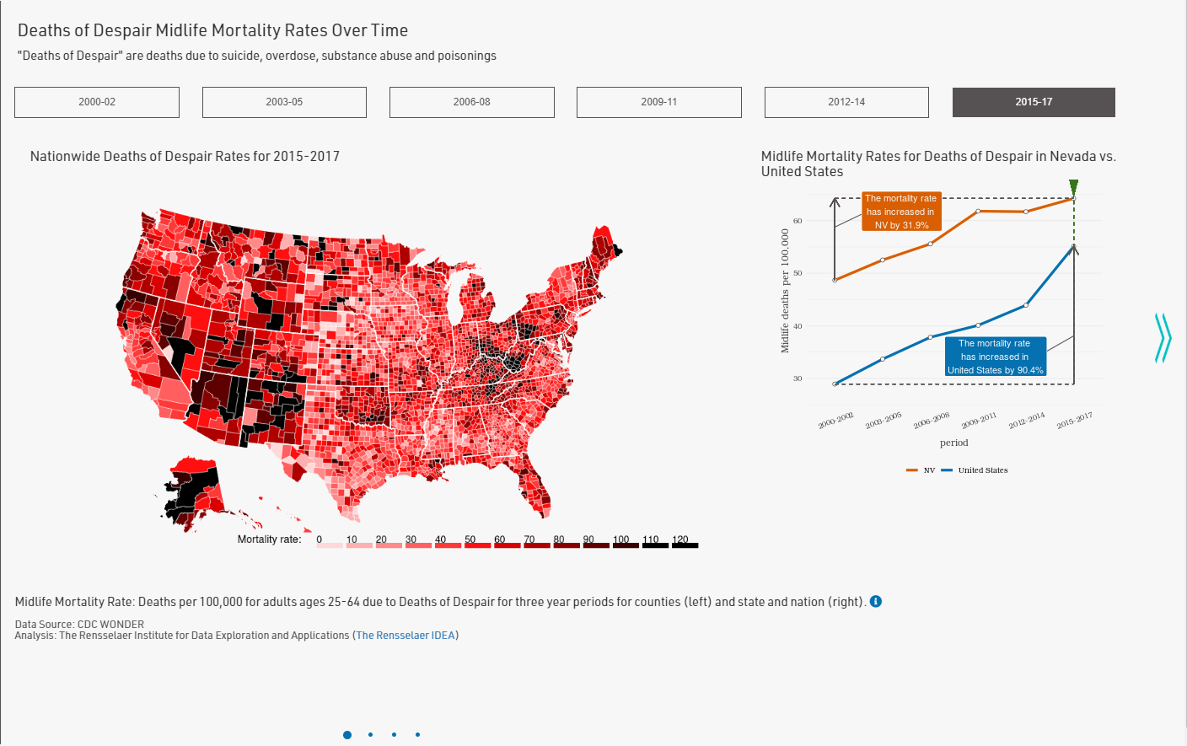2015-2017 National Mortality Distribution:

When we click on the last period, we could tell that the mortality rate has grown rapidly across the nation, which corresponds to the line chart on the right. We can see that Applachian and regions in the southwest have experienced alarming increases. This corresponds to published results in S. Woolf and H. Shoemaker, “Life Expectancy and Mortality Rates in the United States”, 1959-2017, JAMA, November, 2019.

By selecting “United States” for State we can answer the questions “How do midlife mortality rates for Deaths of Despair vary by county across the United States and why?” by clicking the right arrow to get to the “State View” page.

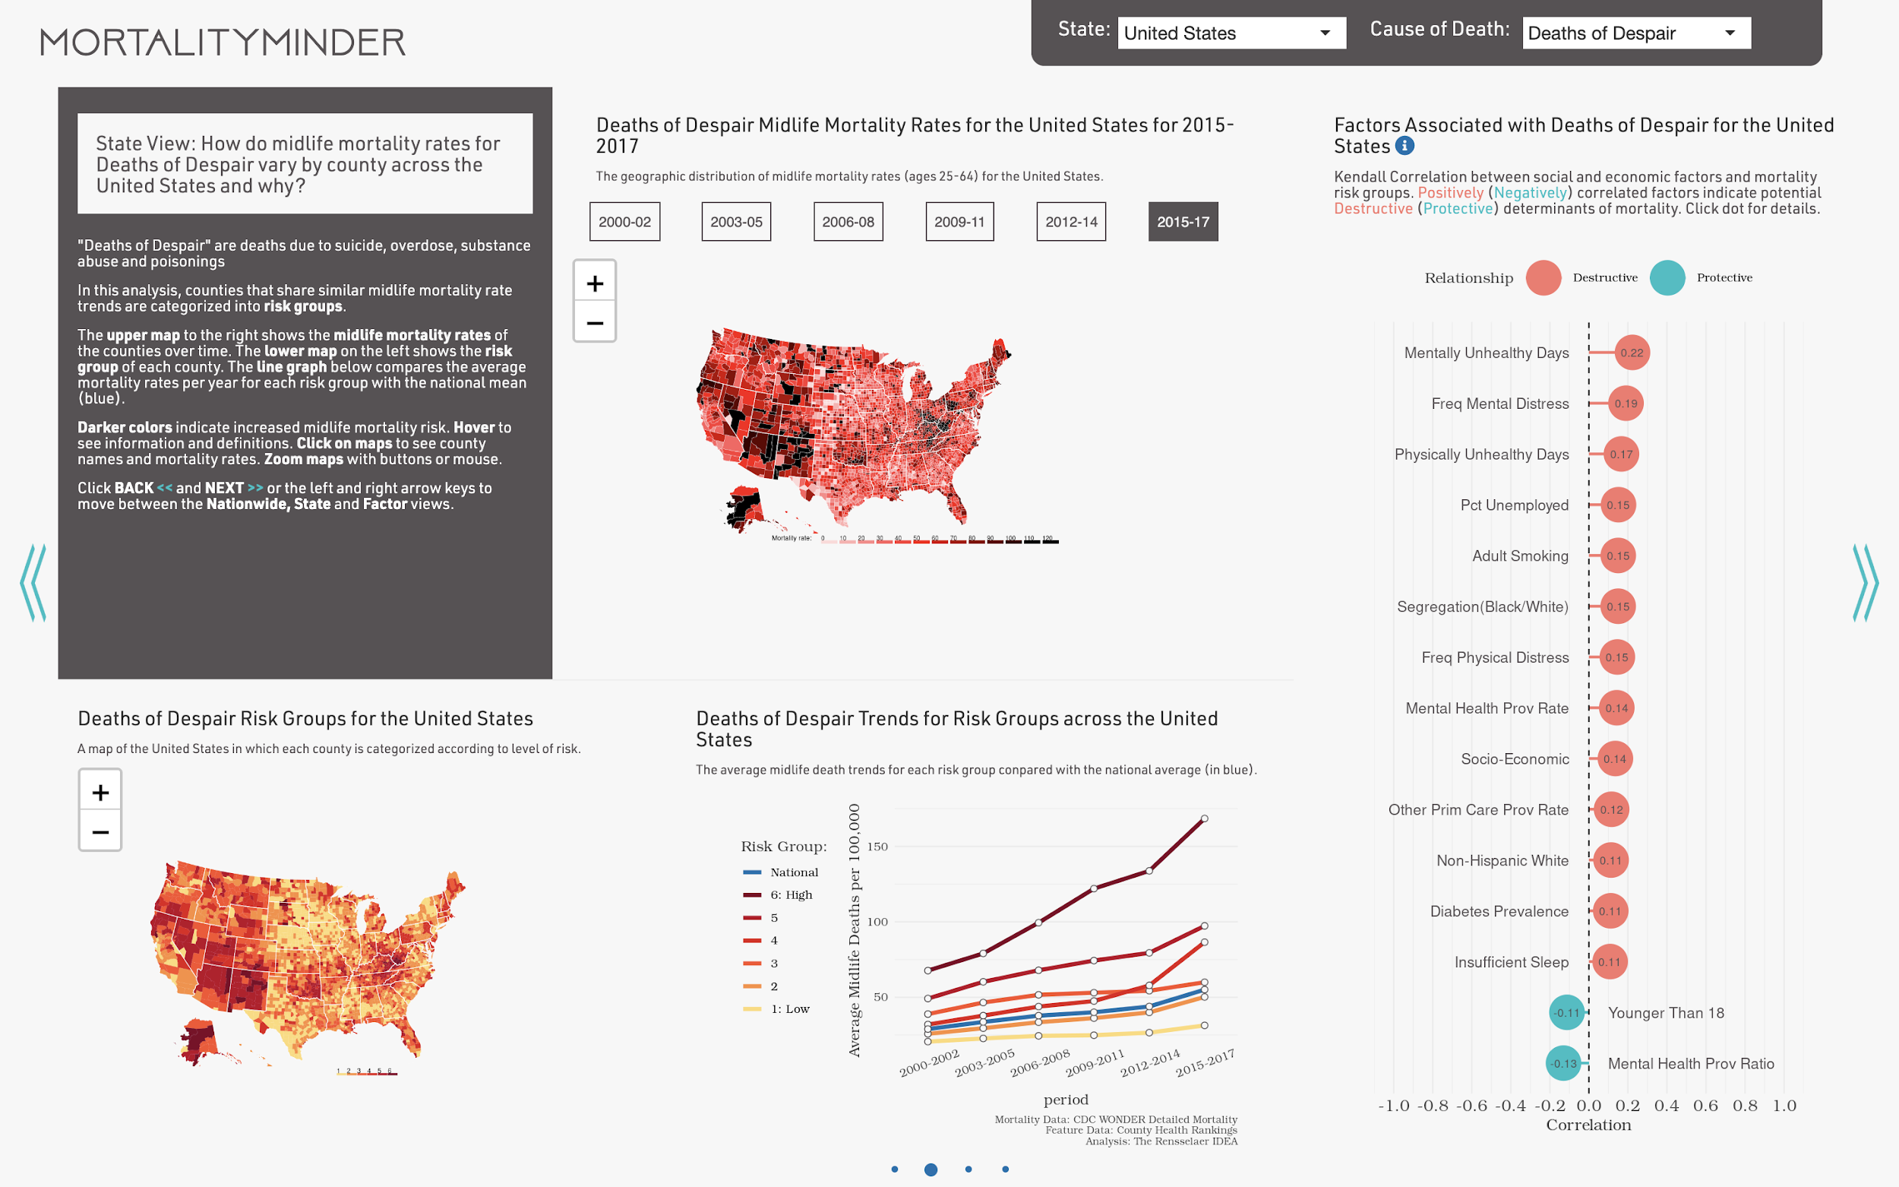

MM divides the counties into 6 risks groups ranging from Group 1 having the least growth in mortality rates and Group 6 having the highest mortality rates over time. Observing the map “Deaths of Despair Rate Groups for the United States” on lower left we can see the higher risk counties are found in the west and Appalachia. The trend line graph shows that on average that on higher Group 6 counties started higher and more than doubled to over 150,000 deaths per 100,000. In contrast Group 1 counties started quite los and had more modest increases.



The right plots show the factors significantly associated with Deaths of Despair. The poor mental health, poor physical health, and unemployment are correlated with high risk group counties. Have good access to mental health care providers and a population with more children are protective factors associated with reduced risk.

In order to have a closer look discrepancies in mortality rate growth, we can look at individual states

**Step 2: CA mortality investigation**

We first take a closer look at California (CA), by selecting California for the state.

Returning the the Nationwide View page, and looking at the line plot we see that CA on average has experienced about a 44% growth in Midlife Mortality Rates due to Deaths of Despair between 2000 and 2017. But the rate of growth has been relatively small since 2003. Thus CA is doing much better than the national trends with regard to Deaths of Despair.

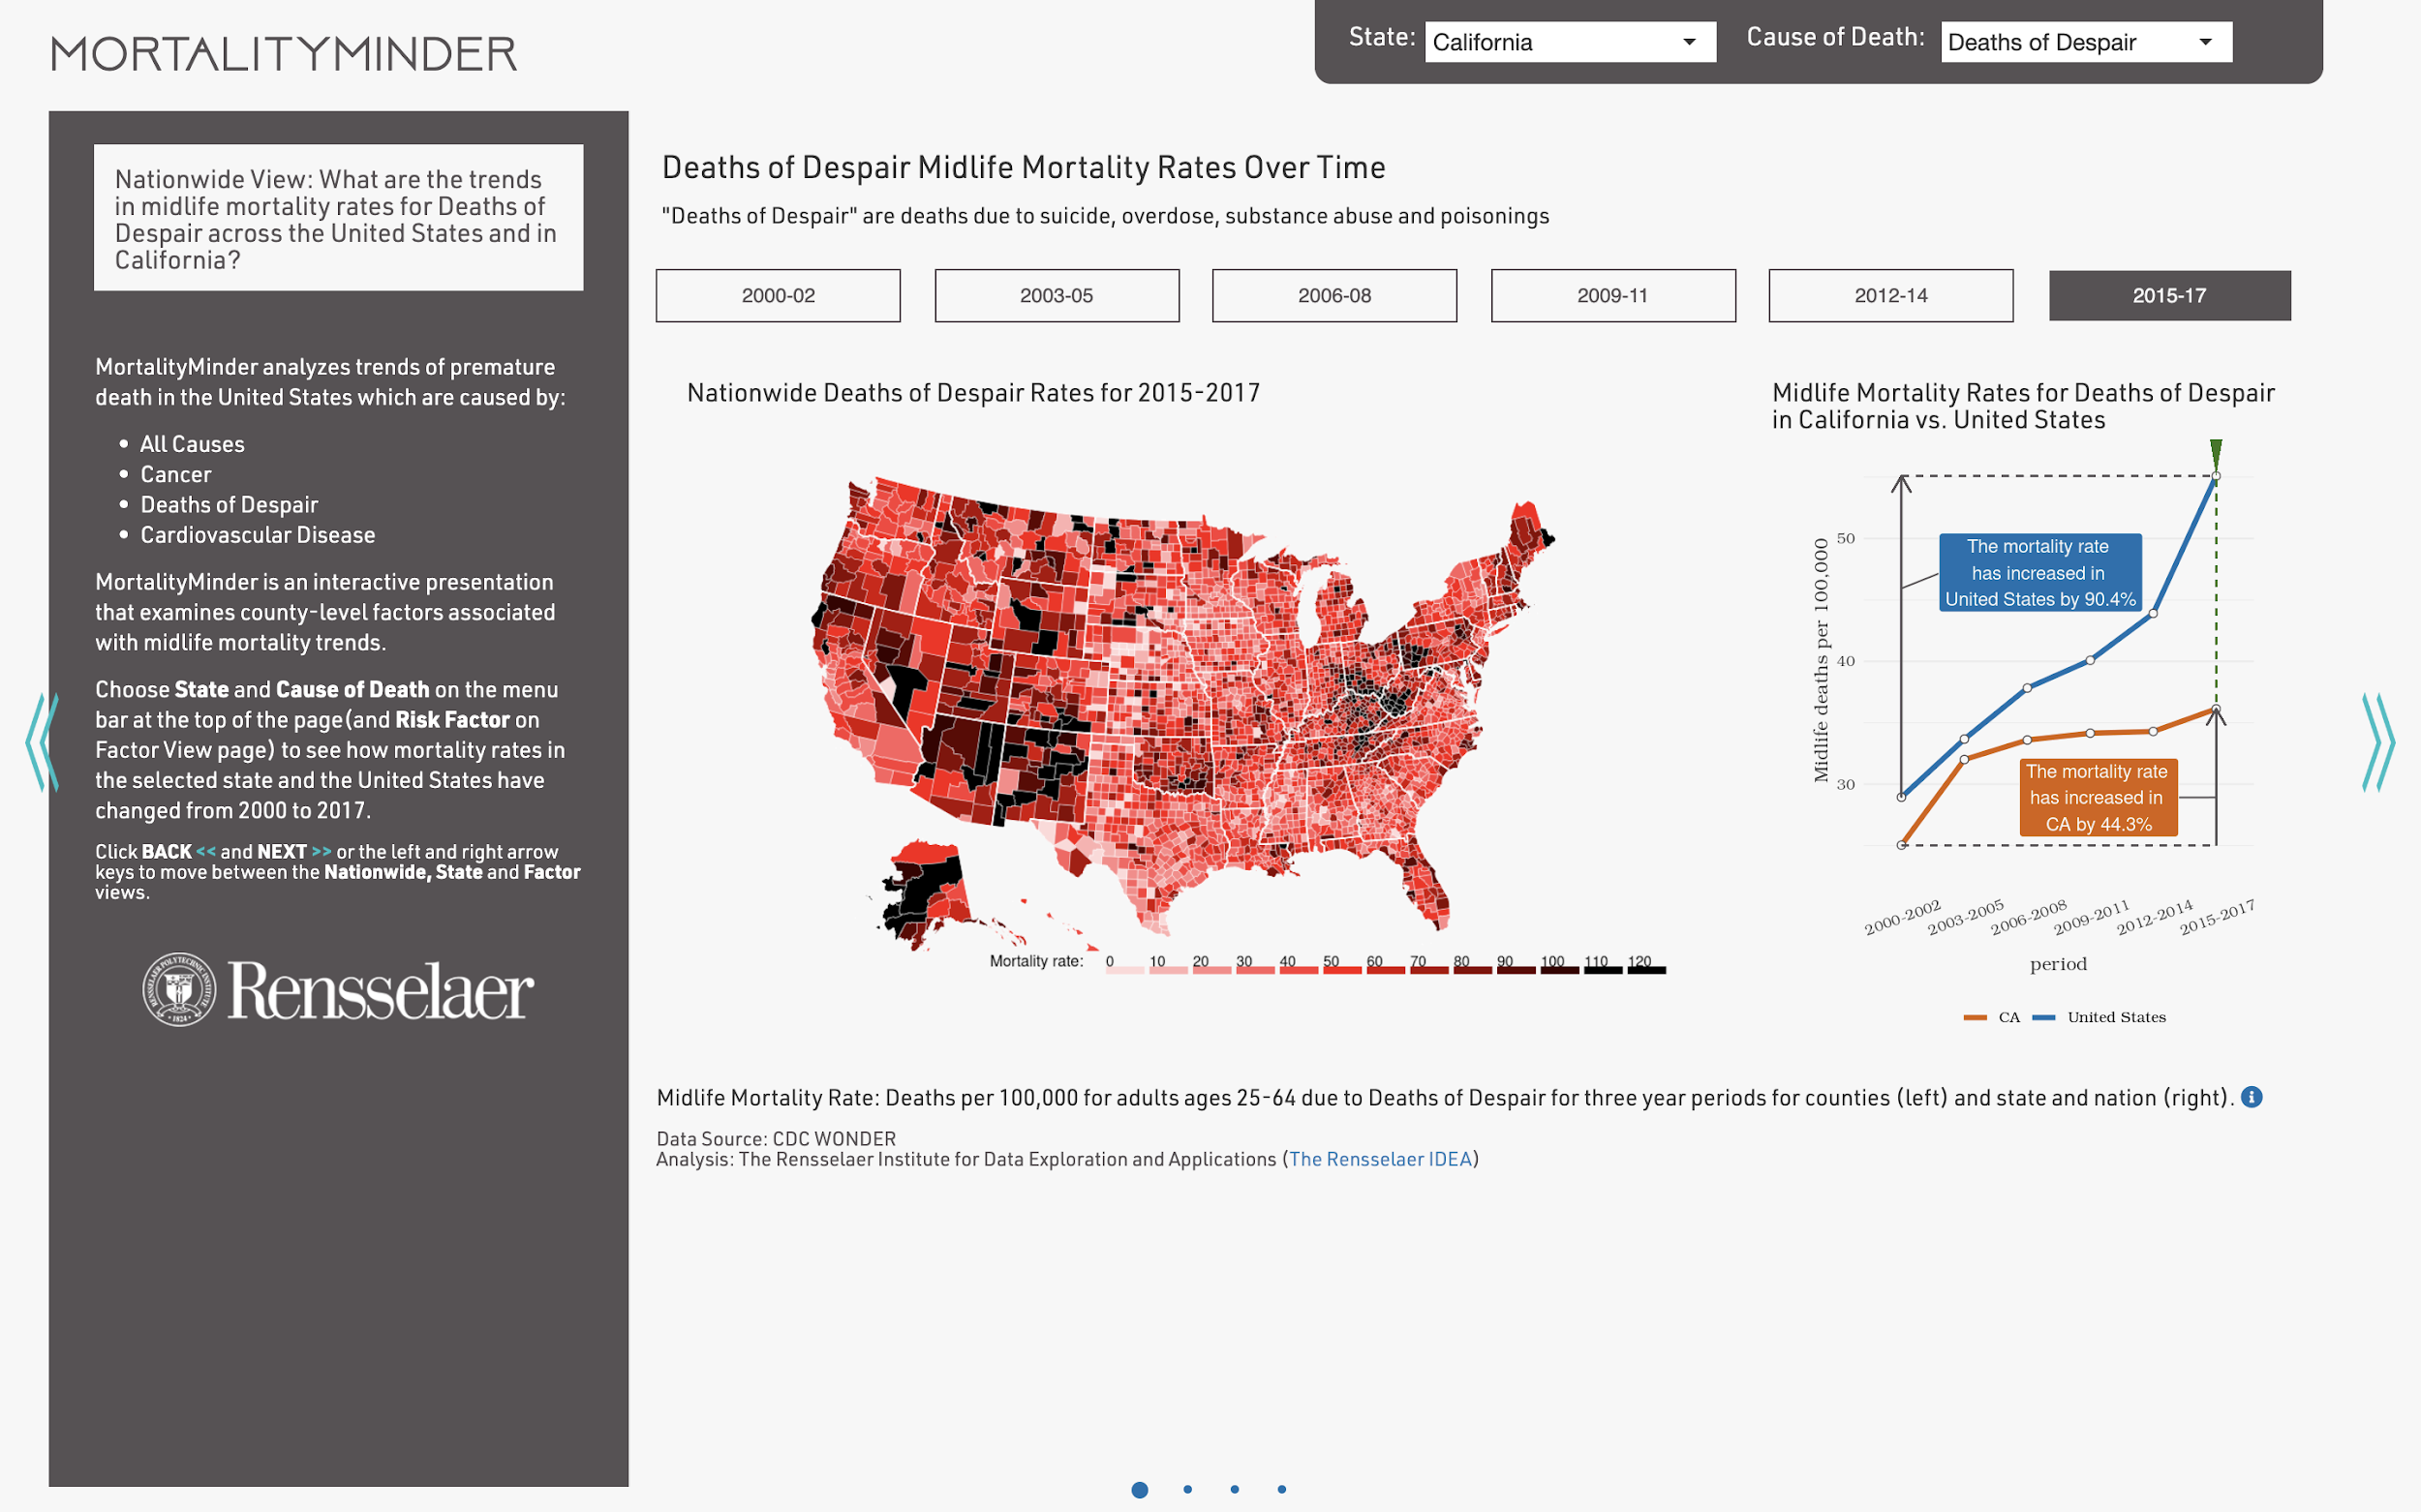

We now move to the State View.

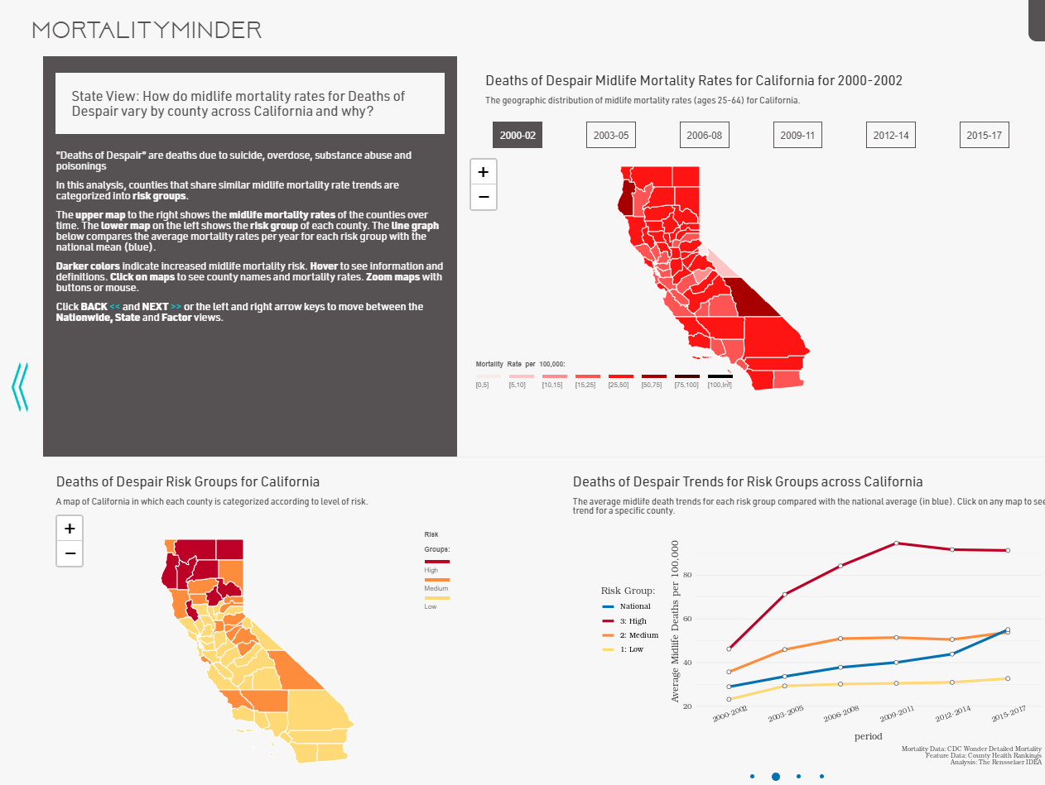

From the line chart, it is obvious that the mortality rate growth have become slower. If we take a look at the map on the left of the line chart, we can tell that only up-state CA is categorized as high-risk group, which corresponds to the red line in the line chart.

But a closer analysis reveals that some parts of CA are doing better than the national average. Because these are the high population areas, the state average is quite good. Parts of CA are experiencing very high mortality rates. Remarkably though, CA has managed to decrease the growth rate of Deaths of Despair. CA may have policies or programs directed toward opiod addiction or suicide that may work for other states. The high risk counties are much worse than the national average. The low risk group contains the major metropolitan areas of CA. These are experiencing much better rates of mortality that are much better than the national average. Though the upstate CA is considered as high-risk group, its mortality rate stops growing after 2011 and even starts going down, which is a good sign. Clearly CA has managed to stem the tide of growth in Deaths of Despair.

**Step 3: NY mortality investigation**

Next let’s take a closer look at NY by selecting New York at the state in the upper right corner.

CA and NY started with similar rates in 2000. Unlike CA, NY is facing continued growth in Deaths of Despair. Overall, NY is doing better than the national trend over the entire time span but the 112% increase in mortality rates within NY is very similar to the growth trend of the entire United States.

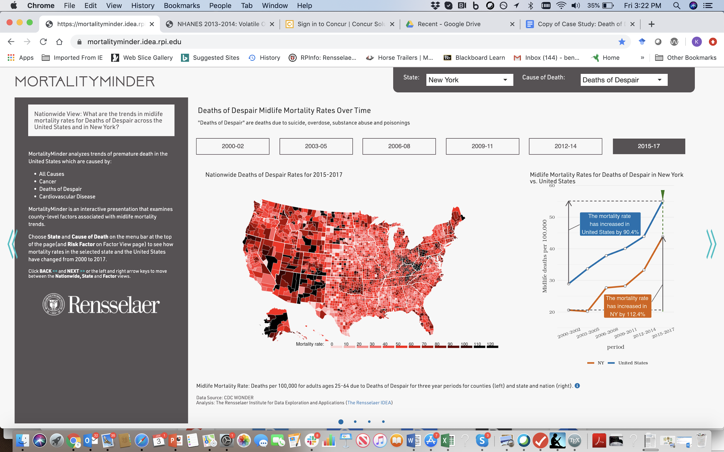

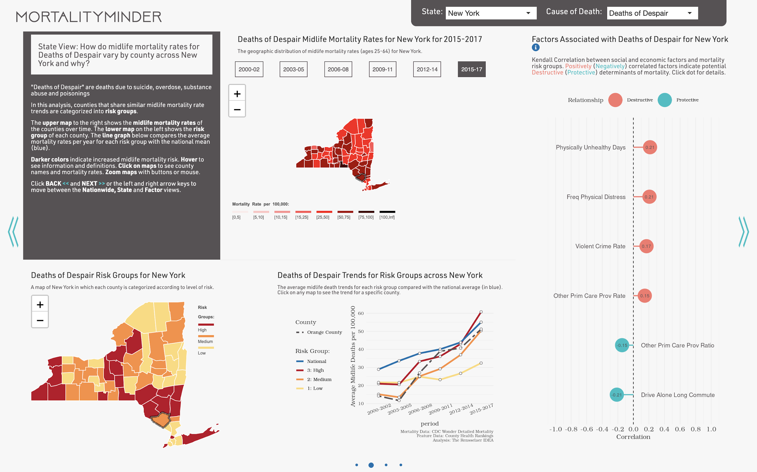

Observe also that in 2000-2002, there were not great disparities between mortality rates in between counties. But then some counties experience more rapid than others. We also note that the medium risk counties in New York had the lowest risk in 2000 but then grew rapidly to outpace other counties. For example, Orange County is shown by a dashed line on the line graph, and we can see that it started with a very low rate and ended near the national average in 2015-2017.

So, what are the possible causes of this difference? We conduct exploratory analysis is to look at the social determinants that are correlated with mortality trends and see how they differ between NY and CA.

**Step 4: Overview of related social determinants.**

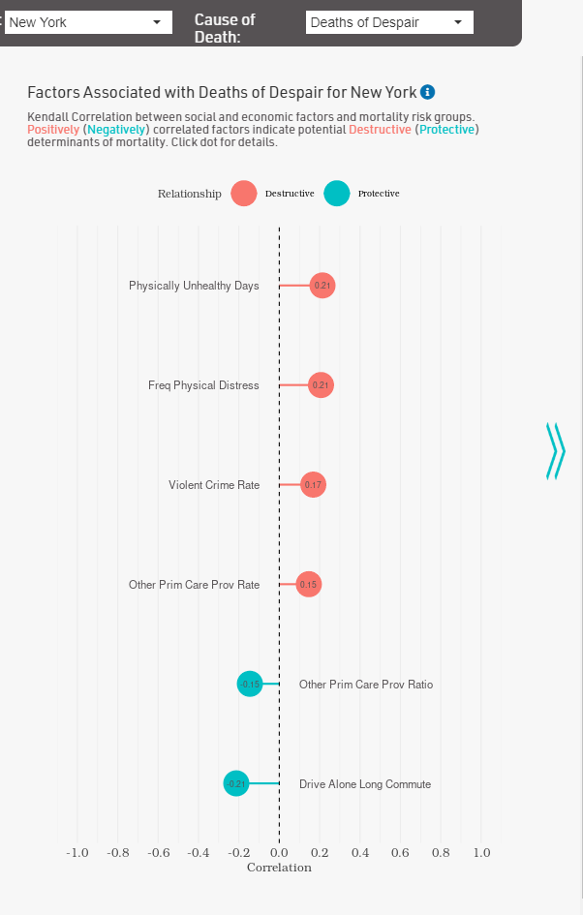Still on the second page, there is a “lollipop chart” on the right of the screen listing top related factors. We compare the factors for California (left) and New York (right)

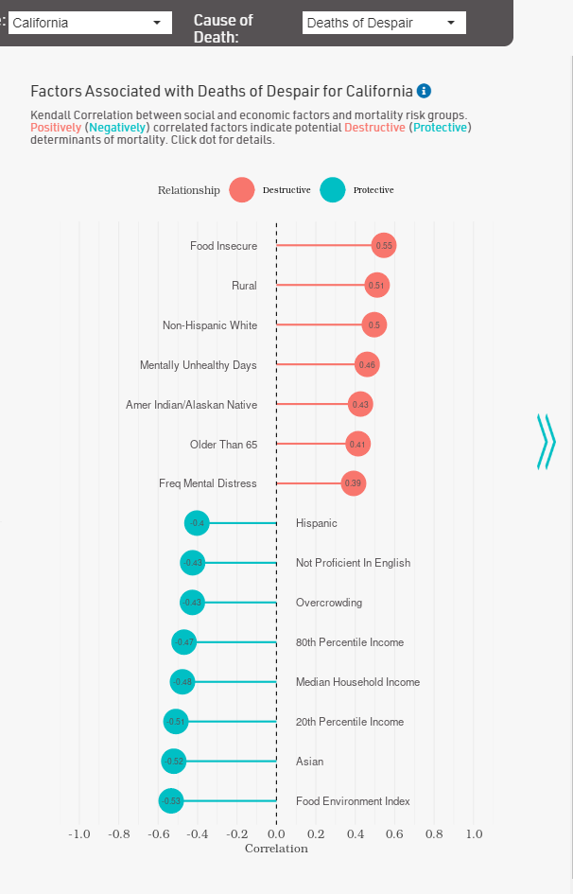

From this variated bar chart, we could see the most related social determinants and rank them based on the strength of correlation. But, such an overview only tells us the mathematically most influential social-economic factors. For CA, we see that Food Insecurity, Rural, Non-hispanic White, and Mentally Unhealthy Days are the top destructive factors while good food access, being Asian, and begin wealthy are protective factors. In NY, the destructive factors are associated with being in physical distress, violent crime, and poor access to primary care providers.

In order to establish hypothesis, we need to examine the meaning of each social determinants and more visualizations about the specific factor, which leads us to the next page. For demonstration, we would only pick the top destructive social determinants for both of the states. So, we would examine “Food Insecure” for CA and “Physically Unhealthy Days” for NY. By simply clicking on the bubble on the lollipop chart, we can jump to the dashboard of the corresponding factor. Here we can see the definition and source of the factor.

**Step 5: CA Food Insecure deep dive**

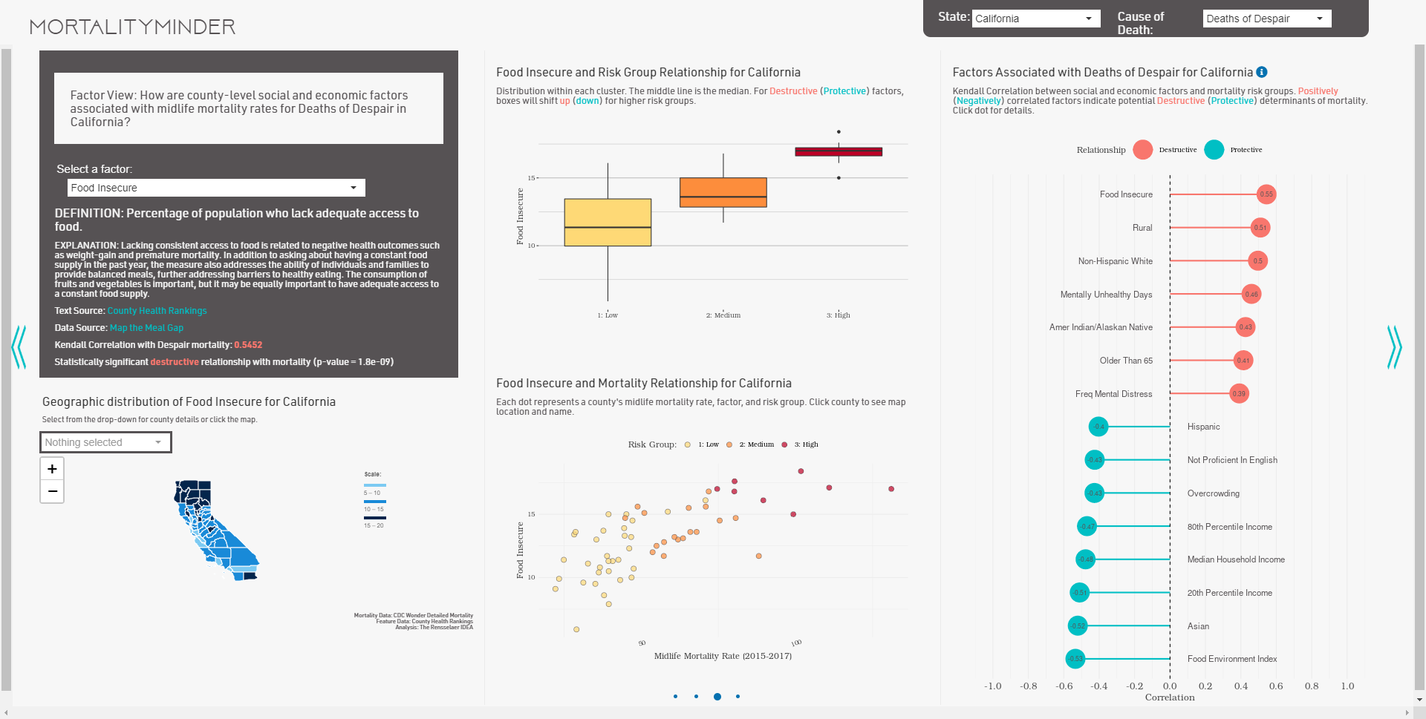

Look at the graphs we see that Food Insecurity occurs in the high risk counties in northern CA. In the lower dot plot, we see that food insecurity is correlated with mortality rates in 2015-2017. We can also see in the higher risk counties face more food insecurity.

**Step 6: NY Physically Unhealthy Days deep dive**

We look at Physically Unhealthy Days for New York on the Factor View. The factor data comes from NHANES (a national survey). The factor defined as “”Average Num physically unhealthy days reported in past 30 days (age-adjusted).” it has higher rates for the medium and high risk counties and lower for the low risk ones.

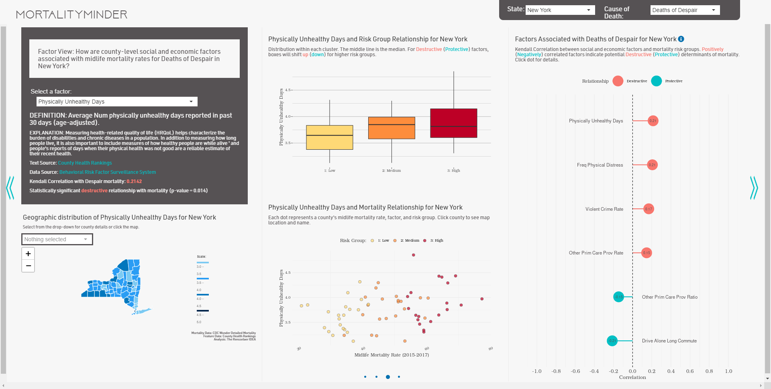

**Step 7: Conclusions**

The analysis above can be finished in approximately half an hour. Within 30 minutes, we can conduct a rather complex exploratory analysis and gain a clear picture about the trends in mortality rates for adults ages 25-64 due to Deaths of Despair at the national level and for two states. Users can explore a state of interest easily to understand georgraphic dicrepencensies in Deaths of Despair trends by county and the factors associated with these differences.